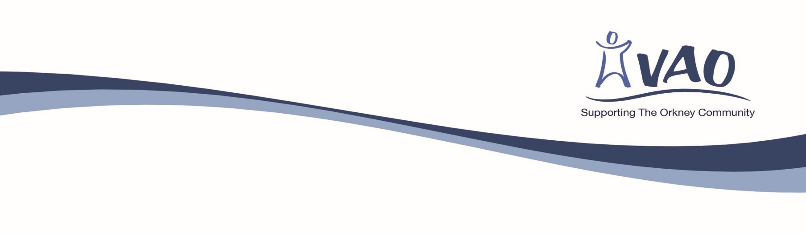

APPLICATION FOR MEMBERSHIP

ORGANISATION
The application form should be completed and signed by your organisation’s nominated representative and co-signed by an office bearer. All membership applications are considered by the VAO Board of Directors. The annual subscription of £15.00 is payable on acceptance as a member.
Name of organisation
Name of representative
Address
Postcode
Email
Tel

Please describe the main aim(s) of your organisation

I understand that in the event of Voluntary Action Orkney being dissolved and leaving debt I may be liable to contribute an amount, not exceeding £1, towards the company’s assets.

Signature of representative
Date

I confirm that the applicant has been nominated to represent the above organisation. |  |  | Invoice address (if different from above)
Name |  |  | Name
Signature |  |  | Address
Position |  |  | Email

Privacy Notice - Members

This privacy notice tells you about the information we collect from you when you become a member of the organisation. In collecting this information, we are acting as a data controller and, by law, we are required to provide you with information about us, about why and how we use your data, and about the rights you have over your data.

Who are we?
We are Voluntary Action Orkney. A Scottish charity, number SC010691, and a company limited by guarantee, number 143208.

You can contact us at: Anchor Buildings, 6 Bridge Street, Kirkwall, KW15 1HR; email: enquiries@vaorkney.org.uk; telephone: 01856 872897.

Any enquiries about our use of your personal data should be addressed to the contact details above.

What personal data do we collect?
When you apply to become a member, if you are an individual, we ask you for your name, address, telephone and email details. If an organisation we ask for your role in the organisation, organisation name, address, email and telephone details.

Why do we collect this information?
We will use your information to maintain and publish a list of members as required by company and charity law.

We require this information to keep you up date with the work of the organisation and to provide you with newsletters, briefing papers and other information that we think might be useful to you. We will also send you notices of AGMs, EGMs, other relevant business meetings and to issue membership reminders annually. In addition, the information we hold ensures that fees are charged to you/your organisation at the membership rate.

What do we do with your information?
Your information is stored in in our members’ records database.

How long do we keep your information for?
We will keep your information for the duration of your membership. Your personal information will then be deleted.

Your rights over your information
By law, you can ask us what information we hold about you, and you can ask us to correct it if it is inaccurate.

You can also ask us to give you a copy of the information and to stop using your information for a period of time if you believe we are not doing so lawfully.

To submit a request by email, post or telephone, please use the contact information provided above.

Your right to complain

If you have a complaint about our use of your information, you can contact the Information Commissioner’s Office via their website at www.ico.org.uk/concerns

