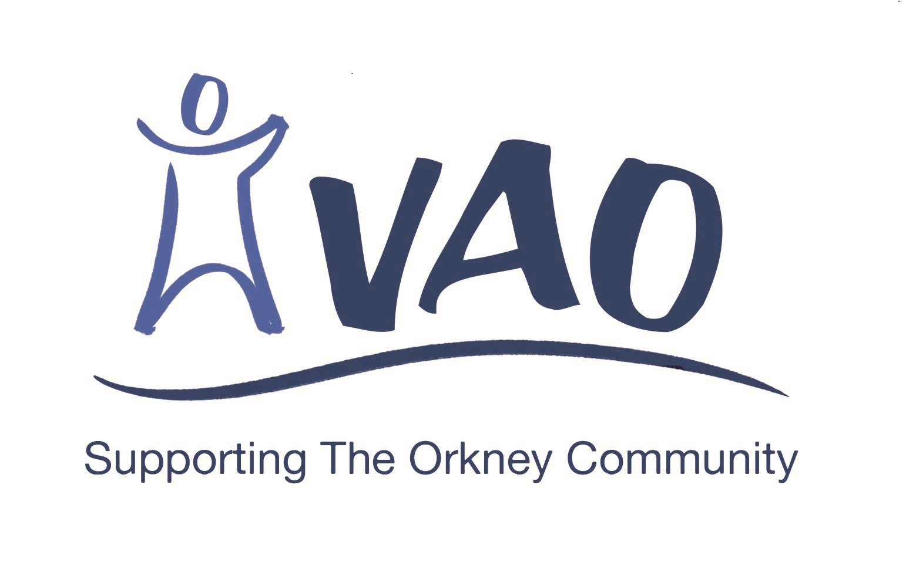

Small Grants Scheme

Application Form

supported by

Liam MacArthur MSP

Applicants are advised to read the associated leaflet
to ensure they meet all the criteria to be considered.

- Your Details

Organisation Name

Project Name

Contact person to whom all correspondence will be sent
Title |  | First Name |  | Surname
Position
Address:

Tel:

Email:

Describe briefly the main purpose of your organisation

2 Your Project/Activity
Please describe your project/activity. Please indicate in some detail the nature of your project including the geographical area, the number of people that will benefit and how it will meet the criteria.

3 Your Project/Activity Costs

- The Total Cost of Your Project/Activity  (this total should not be more than £5000) |  | £
- How much are you requesting from VAO?
(this total should not be more than £500)
- How much are you contributing from your own funds |  | £
- How much is being sought/has been awarded by other funders |  | £
Please give a breakdown of costs for each item/activity if possible
Description |  | Amounts
 |  | £
 |  | £
 |  | £
 |  | £
 |  | £
Total (this should be the same as a)) |  | £
When will the grant be spent?
(it is a condition of award that the grant must be spent by 31 March 2022)

Please provide the name, address and email of an independent referee who has knowledge of, or can confirm, your proposal:
Title |  | First Name |  | Surname
Address and email details

4 PREVIOUS AWARDS
Has your organisation previously received an award from this fund Yes No

if yes, please say when …………………………………….

5 ENCLOSURES
Please ensure that you enclose the following documents with your application:

1 Constitution
2 Most recent Annual Accounts

organisations who have applied previously do not have to resubmit item 1 unless it has changed significantly
ALL applicants must submit item 2

6 SIGNATURES

Chairperson:………………………………………………………………………. Date ……..

Secretary: …………………………………………………………………….. Date ……..

Please return the completed form and enclosures by Friday 21st May 2021 to:

Voluntary Action Orkney,
Anchor Buildings, 6 Bridge Street, Kirkwall KW15 1HR

Or email to kerry.wilson@vaorkney.org.uk

