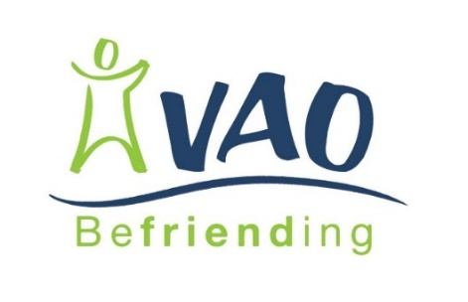
Befriender Registration Form

Our aim is “To reduce loneliness and isolation among older people living in their own homes.”
Name
Address
Telephone Number:
E-mail:
Date of Birth:

Emergency Contact Details
Name |  | Name
Phone number |  | Phone number
Relationship |  | Relationship

References
Please provide 2 referees that you have known for at least 1 year – but not family members
Name |  | Name
Address |  | Address
Email |  | Email
Relationship |  | Relationship

What type of befriending are you interested in? (tick all that apply)
One to One Group Phone

Availability | Morning | Afternoon | Evening
Monday
Tuesday
Wednesday
Thursday
Friday
Saturday
Sunday
I confirm that all the information provided is correct.

Signature

Date

What hobbies and interests do you have?

What qualities do you possess to become a befriender?

Support Needs
If you require support to enable you to volunteer, please provide details.

Transport (volunteer mileage expenses are paid by the Befriending Service)
Do you have a current driving licence & access to a car that you’d be willing to use whilst befriending? Yes No

About You | Gender |  |  |  |  | Age
Please select from the following:
White |  | Asian |  | Black | Mixed |  | Other
Full time employment |  |  | Receiving benefits |  |  | School
Part time employment |  |  | Asylum seeker |  |  | Self-employed
Further education/training |  |  | Unemployed |  |  | Other

How did you hear about VAO Adult Befriending:
Poster | Newspaper | Website | Facebook
Leaflet | Radio | Word of mouth | Other ……………………

